

Technical Report

# Project Methodology Course Assignment

Maksym Sydorovych

Word count



Summary: 690

**Introduction**

A company "Lofthus frukt og saft" located at Hardanger fjord in western Norway have ambitions to expand and find new markets. As part of this process, they need a new website. The main purpose of the site will be to promote and sell its products. They asked to create an online website including all required content (identity elements, articles, photographs, etc.). For now, they only have a logo and a simple brand strategy with no visual aids to use when building a website.

Main section

For the first I drew a sketch with tasks what I use in the Gantt chart.

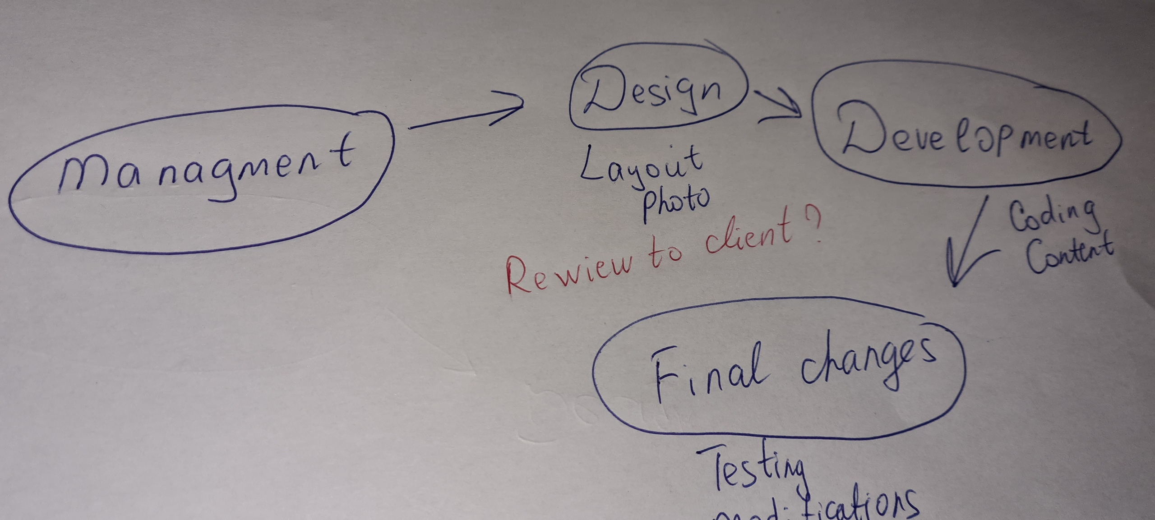

I decided that I would do four main phases of the project which will be broken down into smaller tasks. I made sure that the chart was as simple and understandable as possible, therefore, adding tasks, I then deleted many of them or combined them into one. I decided to take a week as a unit of measurement of work time. When building a chart, I realized that it was necessary to add meetings and presentations of the work done to the client in the tasks. For this project I can take only 5 member of team including myself. The client needs photos for the site, so besides designer, content maker and the front-end developer, I included a photographer in the team and start fill up Gantt chart.

I read about couple of project management softwares. The most i liked Jira which offers various toolbars and add-ons, which allows you to adapt the tool for yourself and customization options for flexible development methodologies. As I understand it, it was originally created for IT teams, therefore, unlike others, it has more useful settings, interesting necessary features for yourself and your team, such as tracking bugs and visibility of the quality of assessing the time of work on a project. Of the free analogs, I liked Kanban Flow. It seemed to me the simplest and most user friendly. So for the project I would use some of project management softwares for control over project work. The main thing that interests me is the feedback from the team members, their reports and dashboards.

From the Learning Gantt Charts course I understood for myself that best choise for buildin Gantt chart at least at first phase of project is creating chart in Exel. This, as a minimum, makes it possible to give access to the chart to any person, without special knowledge and skills.

So I start make chart from building critical path. At the meetings with the client, I decided that it would be best if all team members were involved. I tried to avoid a lot of small tasks to make the project clear and visually beautiful. I make critical path which acctually include all phases of project In one color and all tasks in other. I tried to understand which tasks can be done simultaneously and which must wait for the completion of the previous one. I have highlighted the tasks, if not completed, we can proceed to the next phase, but indicated the maximum possible delay. I tried to give enough time to complete each of the tasks. In the process, I would communicate with each member of the group and plan and break their tasks into smaller ones. Each such period would take one week, which is not very long and does not allow to relax and to do everything at the last moment and not short for have enough time to do everything.

Every morning I would have a 30 minute meeting with all project members, where we would share information about the work and suggestions.

Conclusion

I had training for making Gantt chart for project and work planning on project. Bulding chart alowwed me to better understand how to distribute people and time during planning of project. Gantt chart is great tool fro creating project plan and allows to prepare for possible difficulties. Its helpful for scheduling each task and complete the project on time.